Final Project Design Phase
Computer Science - Week 11
Oct 3, 2026 - Version 0.0.4

For complete instructions and project ideas, refer to the assignment in Canvas. Specifically, review the final project requirements before you continue below. If you have not reviewed the project requirements in Canvas (you might have to go to the modules view and check the current or past week's content), you will not be able to properly complete the parts below. In addition, it may be helpful to review the information on this Drafter documentation page.

0) Project Planning and Preparation
Successful programmers spend time planning before they begin coding. After reviewing the project requirements, answer the following questions to help guide your design and development process.
- What concepts from class or previous assignments might help you complete this project? Which programming concepts (loops, conditionals, lists, classes, etc.) do you expect to use? What programming skills do you want to improve while completing this project?
I will use concepts from previous assignments involving functions, loops, conditional statements, lists, and dataclasses. I expect to use these concepts to store track elements, calculate G forces, and check if the forces are within the threshold. I also want to improve my understanding on using the drafter library in creating my multipage app.

- Which parts of the project do you expect to be the easiest for you? The hardest? Why?
I expect designing the basic structure of the program and creating the input fields to be the easiest parts because they involve concepts I am already familiar with from previous assignments. The hardest parts will probably be implementing the physics calculations accurately and managing the application state. These will require an understanding of physics equations that i am not familiar with right now.

- Even though you have not yet designed the final project, estimate which tasks will likely require the most time and effort? Which features or components should be implemented first?
The physics calculations and track element management system will probably take the most time. I plan to start by creating dataclasses and setting up the application state. Then I will implement the track builder and G force calculations, followed by checking the g force limits. Finally, I will create the remaining pages, improve the user interface, and then test the app.

- What distractions might interfere with your work and how will you minimize them? What resources will you need available while working? What questions, if any, do you still have about the assignment requirements?
My phone and other schoolwork will be my biggest distraction that could interfere with my work. I will minimize these by setting aside dedicated time to work and keeping my phone away while coding. For resources, I will use the previous drafter assignments from class and ChatGPT to help me code.

1) Site Diagram
Create a mock-up of your planned website. We suggest you make the mockup on paper, although you can also use software like PowerPoint or Slides to make a mockup. There is other design software that could also be used, but we strongly encourage you to keep it simple. Do not spend more than 15-30 minutes detailing the mock-up. Your goal should be to make a very quick and dirty diagram, to show that you have some kind of idea.

We recommend drawing each page as a rectangle, and laying out the text, buttons, and other components inside. Then, use arrows to indicate links between pages. Label each page the way you will name each function, and then put labels on the arrows to indicate what the button links. Also write down any parameters that should come into the pages.

In addition to the pages and routes, write down what fields your `State` will have, both their names and types. Think clearly about what data will need to be persistent across the entire website.

Add photo(s) or screenshot(s) of your website mock-up and labeled diagram on the next page.
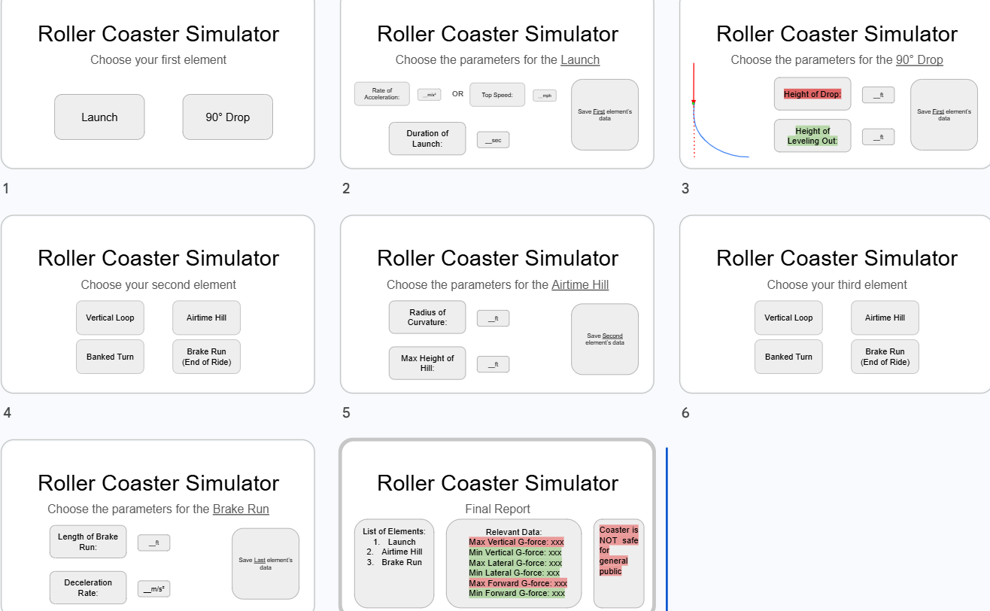

Routes and Navigation:

Index - initial element selection
Launch_page - launch configuration
drop_page - drop configuration
element _selection_page - selection of additional elements
Element_config_page - configuration of the selected element
Add_element_action - saves the element to the coaster
Report_page - displays the final G-force and safety report
Restart_action - allows the user to start a new coaster

2) Implementing Requirements
This table should serve as a draft for how you will implement the requirements into your final project. You may change your ideas later on, but your final site must fulfill all the requirements.

Requirement | Implementation
Purpose/Functionality  A 1-2 sentence description of the purpose or functionality of your site | The website will allow users to build a custom roller coaster by selecting and configuring different track elements. It will calculate the g-forces throughout the coaster and create a report showing all of the g-forces and whether they exceed the legal limit.
State Dataclass Attributes  Minimum of 4 attributes, one of which must be a list/dict of instances of your second dataclass.  Briefly describe each attribute, its type, and how it will be meaningfully modified throughout the site. | Coaster_name: str - stores the coasters name and can be changed by the user  Elements: list[TrackElement] - stores all track elements added by the user  Current_element_type:str - stores the currently selected track element and changes when the user makes a selection.  Current_speed: float - stores the coasters current speed and updates as elements are evaluated  Report: list[str] - stores the results of the g force calculations and updates it when the report is made
Second Dataclass  Your second dataclass, including its attributes, their types, and how they will be meaningfully modified (if they are modified) | TrackElement  Name:str - name of track element  Element_type: str - type of element, such as launch, drop, or banked turn  Entry_speed: float - speed entering element  Vertical_g: float - calculated vertical G force  Lateral_g: float - calculated lateral g force. Each instance is created when an element is added and its calculated values are updated
Routes (minimum 7)  The names of your route functions | Index - initial element selection  Launch_page - launch configuration  drop_page - drop configuration  element _selection_page - selection of additional elements  Element_config_page - configuration of the selected element  Add_element_action - saves the element to the coaster  Report_page - displays the final G-force and safety report  Restart_action - allows the user to start a new coaster
Pages (minimum 5)  A brief description of the pages in your site | Initial Selection: choose a launch or 90 degree drop  Launch configuration: enter acceleration, top speed, and launch duration  Drop configuration: Enter drop height and leveling-out height  Additional Element Selection and Configuration: Choose and configure vertical loops, airtime hills, banked turns, and brake runs. These pages are reused for each element the user adds.  Final Report: Displays the track layout, calculated G forces, and overall safety evaluation.
User Input (minimum 3)  Description of user input components (TextBox, TextArea, CheckBox, or SelectBox) and their purposes  For more information on these input types, see Drafter Documentation. | TextBox: Enter measurements such as height, radius, acceleration, speed, and banking angle  SelectBox: Choose the type of track element to add  CheckBox: allows the user to choose whether the final report shows a visual representation of the coaster track.
If Statements (minimum 3)  Brief description of what will be evaluated in your if statements and how they will meaningfully change the logic of the site | - Check which type of track element was selected to determine which physics calculations to do  - Check whether vertical g-forces exceed the maximum or minimum thresholds and show which elements make it unsafe  - Check whether lateral g-forces exceed the allowed threshold and display a warning  - Checks whether the coaster contains any elements before making the report
Loop (minimum 1)  This loop must iterate over the list/dict of dataclass instances in your State attribute.  Description of this loop and why it is meaningful to the site | A for loop that will go through every TrackElement instance in state.elements. For each element, it will calculate g-forces, evaluate whether it breaks the threshold, and add it to the final report.

LLM Conversation
If you used an LLM in any part of this work, copy and paste every part of that conversation below. Otherwise, you may be given a zero for the assignment. Obviously, these words will not all be yours, and this is the exception to the requirement at the top of this assignment that all responses be in your own words. If you did not use an LLM to assist you in this assignment, simply say so below.
Replace this text with your answer.

Final Submission
When you are finished, download this file as a Word Document (docx) and upload the file to the appropriate assignment on Canvas.

